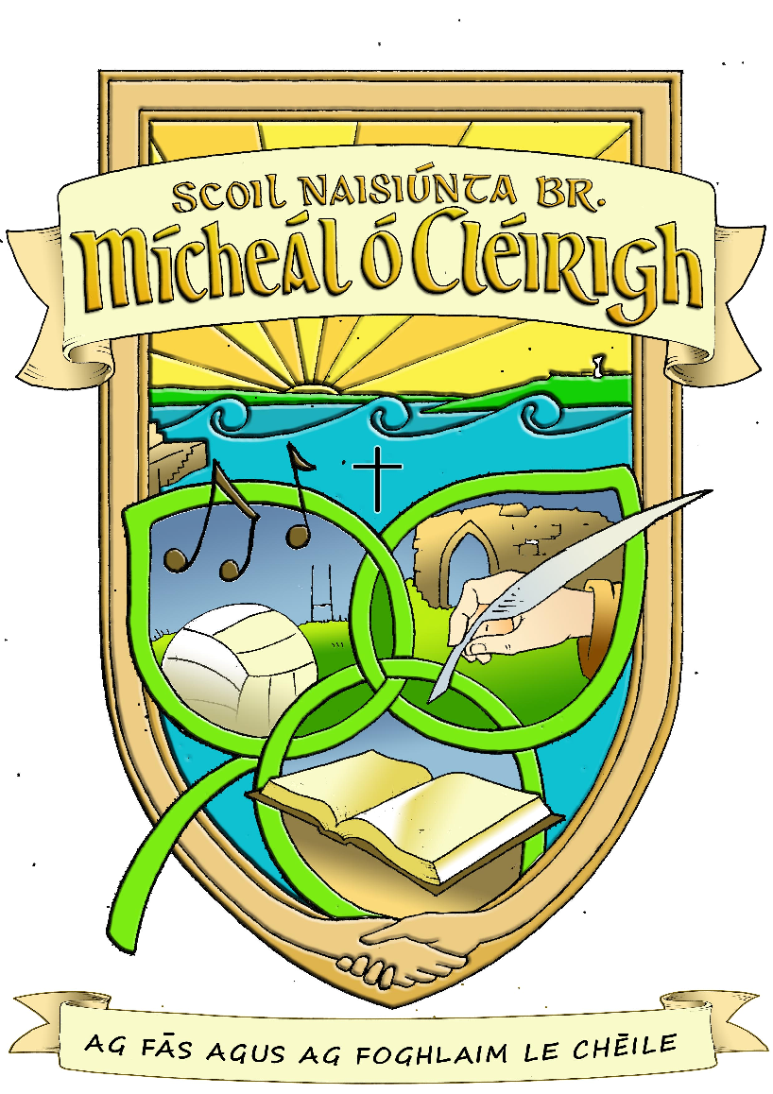

Anti-Bullying Policy

- In accordance with the requirements of the Education (Welfare) Act 2000 and the code of behaviour guidelines issued by the NEWB, the Board of Management of Scoil Náisiúnta Br. Mícheál Ó Cléirigh has adopted the following anti-bullying policy within the framework of the school’s overall code of behaviour. This policy fully complies with the requirements of the Anti-Bullying Procedures for Primary and Post-Primary Schools which were published in September 2013.

- The Board of Management recognises the very serious nature of bullying and the negative impact that it can have on the lives of pupils and is therefore fully committed to the following key principles of best practice in preventing and tackling bullying behaviour:
- A positive school culture and climate which-
  - is welcoming of difference and diversity and is based on inclusivity;
  - encourages pupils to disclose and discuss incidents of bullying behaviour in a non-threatening environment; and
  - promotes respectful relationships across the school community;
- Effective leadership;
- A school-wide approach;
- A shared understanding of what bullying is and its impact;
- Implementation of education and prevention strategies (including awareness raising measures) that-
  - build empathy, respect and resilience in pupils; and
  - explicitly address the issues of cyber-bullying and identity-based bullying including in particular, homophobic and transphobic bullying.
- Effective supervision and monitoring of pupils;
- Supports for staff;
- Consistent recording, investigation and follow up of bullying behaviour (including use of established intervention strategies); and
- On-going evaluation of the effectiveness of the anti-bullying policy.
- In accordance with the Anti-Bullying Procedures for Primary and Post-Primary Schools bullying is defined as follows:
Bullying is unwanted negative behaviour, verbal, psychological or physical, conducted by an individual or group against another person (or persons) and which is repeated over time.
The following types of bullying behaviour are included in the definition of bullying:
- deliberate exclusion, malicious gossip and other forms of relational bullying,
- cyber-bullying and
- identity-based bullying such as homophobic bullying, racist bullying, bullying based on a person’s membership of the Traveller community and bullying of those with disabilities or special educational needs.
Isolated or once-off incidents of intentional negative behaviour, including a once-off offensive or hurtful text message or other private messaging, do not fall within the definition of bullying and should be dealt with, as appropriate, in accordance with the school’s code of behaviour.
However, in the context of this policy, placing a once-off offensive or hurtful public message, image or statement on a social network site or other public forum where that message, image or statement can be viewed and/or repeated by other people will be regarded as bullying behaviour.
Negative behaviour that does not meet this definition of bullying will be dealt with in accordance with the school’s code of behaviour.
Additional information on different types of bullying is set out in Section 2 of the Anti-Bullying Procedures for Primary and Post-Primary Schools.
The list of examples below is non exhaustive.
Examples of bullying behaviours
General behaviours which apply to all types of bullying | - Harassment based on any of the nine grounds in the equality legislation e.g. sexual harassment, homophobic bullying, racist bullying etc.  - Physical aggression  - Damage to property  - Name calling  - Slagging  - The production, display or circulation of written words, pictures or other materials aimed at intimidating another person  - Offensive graffiti  - Extortion  - Intimidation  - Insulting or offensive gestures  - The “look”  - Invasion of personal space  - A combination of any of the types listed.
Cyber | - Denigration: Spreading rumors, lies or gossip to hurt a person’s reputation  - Harassment: Continually sending vicious, mean or disturbing messages to an individual  - Impersonation: Posting offensive or aggressive messages under another person’s name  - Flaming: Using inflammatory or vulgar words to provoke an online fight  - Trickery: Fooling someone into sharing personal information which you then post online  - Outing: Posting or sharing confidential or compromising information or images  - Exclusion: Purposefully excluding someone from an online group  - Cyber stalking: Ongoing harassment and denigration that causes a person considerable fear for his/her safety  - Silent telephone/mobile phone call  - Abusive telephone/mobile phone calls  - Abusive text messages  - Abusive email  - Abusive communication on social networks e.g. Facebook/Ask.fm/ Twitter/You Tube or on games consoles  - Abusive website comments/Blogs/Pictures  - Abusive posts on any form of communication technology
Identity Based Behaviours
Including any of the nine discriminatory grounds mentioned in Equality Legislation (gender including transgender, civil status, family status, sexual orientation, religion, age, disability, race and membership of the Traveller community).
Homophobic and Transgender | - Spreading rumours about a person’s sexual orientation  - Taunting a person of a different sexual orientation  - Name calling e.g. Gay, queer, lesbian...used in a derogatory manner  - Physical intimidation or attacks  - Threats
Race, nationality, ethnic background and membership of the Traveller community | - Discrimination, prejudice, comments or insults about colour, nationality, culture, social class, religious beliefs, ethnic or traveller background  - Exclusion on the basis of any of the above
Relational | This involves manipulating relationships as a means of bullying. Behaviours include:  - Malicious gossip  - Isolation & exclusion  - Ignoring  - Excluding from the group  - Taking someone’s friends away  - “Bitching”  - Spreading rumours  - Breaking confidence  - Talking loud enough so that the victim can hear  - The “look”  - Use or terminology such as ‘nerd’ in a derogatory way
Sexual | - Unwelcome or inappropriate sexual comments or touching  - Harassment
Special Educational Needs,  Disability | - Name calling  - Taunting others because of their disability or learning needs  - Taking advantage of some pupils’ vulnerabilities and limited capacity to recognise and defend themselves against bullying  - Taking advantage of some pupils’ vulnerabilities and limited capacity to understand social situations and social cues.  - Mimicking a person’s disability  - Setting others up for ridicule

- The relevant teacher(s) for investigating and dealing with bullying is (are) as follows: (see Section 6.8 of the Anti-Bullying Procedures for Primary and Post-Primary Schools):

The class teacher(s) of the pupil(s) involved. This may include learning support/resource teacher(s) of the pupil(s) involved, and the principal or deputy principal, where appropriate.

- The education and prevention strategies (including strategies specifically aimed at cyber- bullying and identity-based bullying including in particular, homophobic and transphobic bullying) that will be used by the school are as follows (see Section 6.5 of the Anti-Bullying Procedures for Primary and Post-Primary Schools):
- Model respectful behaviour to all members of the school community at all times.
- Explicitly teach pupils what respectful language and respectful behaviour looks like, acts like, sounds like and feels like in class and around the school.
- Display key respect messages in classrooms, in assembly areas and around the school. Involve pupils in the development of these messages.
- Catch them being good - notice and acknowledge desired respectful behaviour by providing positive attention.
- Consistently tackle the use of discriminatory and derogatory language in the school – this includes homophobic and racist language and language that is belittling of pupils with a disability or SEN.
- Give constructive feedback to pupils when respectful behaviour and respectful language are absent.
- Have a system of encouragement and rewards to promote desired behaviour and compliance with the school rules and routines.
- Explicitly teach pupils about the appropriate use of social media.
- Positively encourage pupils to comply with the school rules on mobile phone and internet use.
- Follow up and follow through with pupils who ignore the rules.
- Actively involve parents and/or the Parents’ Association in awareness raising campaigns around social media.
- Actively promote the right of every member of the school community to be safe and secure in school.
- Highlight and explicitly teach school rules in pupil friendly language in the classroom and in common areas.
- All staff watch out for signs of bullying behaviour.
- Ensure there is adequate playground/school yard/outdoor supervision.
- School staff can get pupils to help them to identify bullying “hot spots” and “hot times” for bullying in the school. Hot spots tend to be in the playground/school yard/outdoor areas, changing rooms, corridors and other areas of unstructured supervision. Hot times again tend to be times where there is less structured supervision such as when pupils are in the playground/school yard or moving classrooms.
- Involve the Student Council in contributing to a safe school environment e.g. playground helpers, buddy system and other activities that help support pupils and encourage a culture of peer respect and support.
- Use the elements of SPHE and religion which make specific provision for exploring bullying as well as the inter-related areas of belonging and integrating, communication, conflict, friendship, personal safety and relationships. The Stay Safe programme is a personal safety skills programme which seeks to enhance children’s self-protection skills including their ability to recognise and cope with bullying. Other programmes such as RSE, Walk Tall and Webwise.ie resources are utilised to support the SPHE curriculum.
- A Friendship (Anti-Bullying) Week takes place in the school annually. All classes are involved in anti-bullying lessons and activities which take place throughout the week. Teachers utilise the webwise.ie resources
- Safer Internet Day takes place annually and is prioritised in the school.
- The school reminds parents of the dangers of "cyber- bullying" on social networking sites, gaming platforms and mobile phones. We also direct their attention to the school's internet Acceptable Use Policy (AUP).
- Pupil of the Week awards are given to pupils at assembly to promote good behaviour or effort in classrooms.
- Continuous Professional Development for staff in relation to behaviour management/ bullying/ child protection or SPHE.

- The school’s procedures for investigation, follow-up and recording of bullying behaviour and the established intervention strategies used by the school for dealing with cases of bullying behaviour are as follows (see Section 6.8 of the Anti-Bullying Procedures for Primary and Post-Primary Schools) :

Procedure for Investigating and Dealing with Bullying
- The primary aim for the relevant teacher in investigating and dealing with bullying is to resolve any issues and to restore, as far as is practicable, the relationships of the parties involved (rather than to apportion blame);
- In investigating and dealing with bullying, the teacher will exercise his/her professional judgement to determine whether bullying has occurred and how best the situation might be resolved;
- Any pupil or parent/guardian may bring a bullying incident to any teacher in the school. All reports, including anonymous reports of bullying must be investigated and dealt with by the relevant teacher. In that way pupils will gain confidence in ‘telling’. This confidence factor is of vital importance. It should be made clear to all pupils that when they report incidents of bullying they are not considered to be telling tales but are behaving responsibly;
- Teaching and non-teaching staff such as secretaries, special needs assistants (SNAs), caretakers, cleaners must be encouraged to report any incidents of bullying behaviour witnessed by them, or mentioned to them, to the relevant teacher;
- Parents and pupils are required to cooperate with any investigation and assist the school in resolving any issues and restoring, as far as is practicable, the relationships of the parties involved as quickly as possible;
- It is important that all involved (including each set of pupils and parents) understand the approach for dealing with reported bullying from the outset;
- Teachers should take a calm, unemotional problem-solving approach when dealing with incidents of alleged bullying behaviour reported by pupils, staff or parents; drawing on restorative questions where appropriate.
- Incidents are generally best investigated outside the classroom situation to ensure the privacy of all involved;
- All interviews should be conducted with sensitivity and with due regard to the rights of all pupils concerned. Pupils who are not directly involved can also provide very useful information in this way;
- When analysing incidents of bullying behaviour, the relevant teacher should seek answers to questions of what, where, when, who and why. This should be done in a calm manner, setting an example in dealing effectively with a conflict in a non-aggressive manner;
- If a group is involved, each member should be interviewed individually at first. Thereafter, all those involved should be met as a group. At the group meeting, each member should be asked for his/her account of what happened to ensure that everyone in the group is clear about each other’s statements;
- Each member of a group should be supported through the possible pressures that they may face them from the other members of the group after interview by the teacher;
- It may also be appropriate or helpful to ask those involved to write down their account of the incident(s);
- In cases where it has been determined by the relevant teacher that bullying behaviour has occurred, the parents of the parties involved should be contacted at an early stage to inform them of the matter and explain the actions being taken (by reference to the school policy). The school should give parents an opportunity to discuss ways in which they can reinforce or support the actions being taken by the school and the supports for their pupils;

- Where the relevant teacher has determined that a pupil has been engaged in bullying behaviour, it should be made clear to him/her how he/she is in breach of the school’s anti-bullying policy and efforts should be made to try to get him/her to see the situation from the perspective of the pupil being bullied.

- It must also be made clear to all involved (each set of pupils and parents) that in any situation where disciplinary sanctions are required, this is a private matter between the pupil being disciplined, his or her parents and the school;
Follow up and recording

- In determining whether a bullying case has been adequately and appropriately addressed the relevant teacher must, as part of his/her professional responsibility, take the following factors into account:
  - Whether the bullying behaviour has ceased;
  - Whether any issues between the parties have been resolved as far as is practicable;
  - Whether the relationships between the parties have been restored as far as is practicable; and
  - Any feedback received from the parties involved, their parents or the school Principal or Deputy Principal;
- Follow-up meetings with the relevant parties involved should be arranged separately with a view to possibly bringing them together at a later date if the pupil who has been bullied is ready and agreeable.
- Where a parent is not satisfied that the school has dealt with a bullying case in accordance with these procedures, the parents must be referred, as appropriate, to the school’s complaints procedures;
- In the event that a parent has exhausted the school's complaints procedures and is still not satisfied, the school must advise the parents of their right to make a complaint to the Ombudsman for Children.
Procedures for recording bullying behaviour
- It is imperative that all recording of bullying incidents must be done in an objective and factual manner.
- The school’s procedures for noting and reporting bullying behaviour are as follows:
Informal- pre-determination that bullying has occurred
  - All staff must keep a written record of any incidents witnessed by them or notified to them in their classroom notebook.
  - All incidents must be reported to the relevant teacher
  - While all reports, including anonymous reports of bullying must be investigated and dealt with by the relevant teacher, the relevant teacher must keep a written record of the reports, the actions taken and any discussions with those involved regarding same
  - The relevant teacher must inform the principal of all incidents being investigated.
Formal Stage 1-determination that bullying has occurred
- If it is established by the relevant teacher that bullying has occurred, the relevant teacher must keep appropriate written records which will assist his/her efforts to resolve the issues and restore, as far as is practicable, the relationships of the parties involved.
- The relevant teacher/s should record the report(s) received and the findings of the investigation in the school’s Anti-bullying Policy Record Book which is stored in the Principal’s Office.
- The recording template at Appendix 3 will be used by the relevant teacher(s). All records must be maintained in accordance with relevant data protection legislation. The school’s procedures for noting and reporting bullying behaviour must adhere to the following:
  - The recording template at Appendix 3 must be completed in full and retained by the teacher in question and a copy provided to the Principal or Deputy Principal as applicable to store in the Anti-bullying Record Book.
  - It should also be noted that the timeline for recording bullying behaviour in the recording template at Appendix 3 does not in any way preclude the relevant teacher from consulting the Principal or Deputy Principal at an earlier stage in relation to a case.
- Information regarding any past bullying issues will be passed on to a new teacher at the start of each year.

Bullying as part of a continuum of behaviour

It is also important to note that bullying behaviour can be part of a continuum of behaviour rather than a stand-alone issue and in some cases behaviour may escalate beyond that which can be described as bullying to serious physical or sexual assault or harassment. In cases where a school has serious concerns in relation to managing the behaviour of a pupil, the advice of the National Education Psychological Service (NEPS) will be sought and may result in referral of serious cases to the HSE.

In relation to bullying in schools, Children First National Guidance for the Protection and Welfare of Children 2011 (Children First) and the Child Protection Procedures for Primary and Post-Primary Schools provide that in situations where “the incident is serious and where the behaviour is regarded as potentially abusive, the school must consult Tusla Children and Family Agency with a view to drawing up an appropriate response, such as a management plan”.

Serious instances of bullying behaviour should, in accordance with the Children First and the Child Protection Procedures for Primary and Post-Primary Schools, be referred to Tusla Children and Family Agency and/or Gardaí as appropriate.
The Child Protection Procedures for Primary and Post-Primary Schools also provide that where school personnel have concerns about a child but are not sure whether to report the matter to Tusla, the Designated Liaison Person must seek advice from Tusla, Children and Family Agency.

Procedure for dealing with cases of bullying behaviour which occur on school transport:
- Incidents of bullying can extend beyond the school and the journey to and from school is one which can provide particular opportunities for bullying to occur.
- A copy of the school's anti-bullying policy will be given to all providers of school transport in Creevy National School.
- If a pupil makes a complaint of bullying on the school bus, their parents will be contacted. If a parent contacts the school regarding incidents of bullying on the bus, the principal will:
  - Refer the parents to the bus driver and inform them of Bus Eireann’s policy: “Guidelines for Discipline and Procedures for Dealing with Alleged Misbehaviour on School Transport”
  - Refer the parents to the bus inspector. The school will also contact the inspector to inform them of the complaint received.
  - If the complaint isn’t dealt with within 10 school days, then the school’s anti-bullying procedures will be referred to.

- The school’s programme of support for working with pupils affected by bullying is as follows (see Section 6.8 of the Anti-Bullying Procedures for Primary and Post-Primary Schools) :
- All in-school supports and opportunities will be provided for the pupils affected by bullying and they will be encouraged to participate in activities designed to raise their self-esteem, to develop friendships and social skills and build resilience e.g. Buddy/Peer mentoring system, groups work such as circle time, organised activities, additional support by support teachers, pastoral care.
- If pupils require counselling or further supports the school will endeavour to liaise with the appropriate agencies to organise same. This may be for the pupil affected by bullying or engaging in the bullying behaviour.
- Pupils should understand that there are no innocent bystanders and that all incidents of bullying behaviour must be reported to a teacher.

- Supervision and Monitoring of Pupils
The Board of Management confirms that appropriate supervision and monitoring policies and practices are in place to both prevent and deal with bullying behaviour and to facilitate early intervention where possible.

- Prevention of Harassment
The Board of Management confirms that the school will, in accordance with its obligations under equality legislation, take all such steps that are reasonably practicable to prevent the sexual harassment of pupils or staff or the harassment of pupils or staff on any of the nine grounds specified i.e. gender including transgender, civil status, family status, sexual orientation, religion, age, disability, race and membership of the Traveller community.

This policy has been made available to school personnel, is published on the school website and provided to the Parents’ Association. A copy of this policy will be made available to the Department and the patron if requested.

This policy and its implementation will be reviewed by the Board of Management once in every school year. Written notification that the review has been completed will be made available to school personnel, will be published on the school website and provided to the Parents’ Association. A record of the review and its outcome will be made available, if requested, to the patron and the Department.
This policy was reviewed by the Board of Management on 22rd March 2023
Signed: _____________________________ (Chairperson) Next review: Mar 2024

Appendix 4 Checklist for annual review of the anti-bullying policy and its implementation
The Board of Management (the Board) must undertake an annual review of the school’s anti-bullying policy and its implementation. The following checklist must be used for this purpose. The checklist is an aid to conducting this review and is not intended as an exhaustive list. In order to complete the checklist, an examination and review involving both quantitative and qualitative analysis, as appropriate across the various elements of the implementation of the school’s anti-bullying policy will be required.
Yes /No
Has the Board formally adopted an anti-bullying policy that fully complies with the requirements of the Anti-Bullying Procedures for Primary and Post-Primary Schools? | yes
Has the Board published the policy on the school website and provided a copy to the parents’ association? | yes
Has the Board ensured that the policy has been made available to school staff (including new staff)? | yes
Is the Board satisfied that school staff are sufficiently familiar with the policy and procedures to enable them to effectively and consistently apply the policy and procedures in their day to day work? | yes
Has the Board ensured that the policy has been adequately communicated to all pupils? | yes
Has the policy documented the prevention and education strategies that the school applies? | yes
Have all of the prevention and education strategies been implemented? | yes
Has the effectiveness of the prevention and education strategies that have been implemented been examined? | yes
Is the Board satisfied that all teachers are recording and dealing with incidents in accordance with the policy? | yes
Has the Board received and minuted the periodic summary reports of the Principal? | yes
Has the Board discussed how well the school is handling all reports of bullying including those addressed at an early stage and not therefore included in the Principal’s periodic report to the Board? | yes
Has the Board received any complaints from parents regarding the school’s handling of bullying incidents? | no
Have any parents withdrawn their child from the school citing dissatisfaction with the school’s handling of a bullying situation? | no
Have any Ombudsman for Children investigations into the school’s handling of a bullying case been initiated or completed? | no
Has the data available from cases reported to the Principal (by the bullying recording template) been analysed to identify any issues, trends or patterns in bullying behaviour? | yes
Has the Board identified any aspects of the school’s policy and/or its implementation that require further improvement? | no
Has the Board put in place an action plan to address any areas for improvement? | n/a

Signed: Date 22/3/23
Chairperson, Board of Management

Notification regarding the Board of Management’s annual review of the anti-bullying policy

To: Parents’ Association

The Board of Management of Creevy N.S. wishes to inform you that:

o The Board of Management’s annual review of the school’s anti-bullying policy and its implementation was completed at the Board meeting of 23/3/22.

o This review was conducted in accordance with the checklist set out in Appendix 4 of the Department’s Anti-Bullying Procedures for Primary and Post-Primary Schools.

Signed: Date 22/3/23

